CTCSS tone generator

- All existing CTCSS (PL) tones can be generated

- Additional sel-call tones

- Few components needed

Principal

A single PIC controller is used to produce a signal close to a clean sinewave which is stored into a table of 64 bytes in the memory of the processor. Each value of the sinewave consists of 4 bits, this is the resolution:

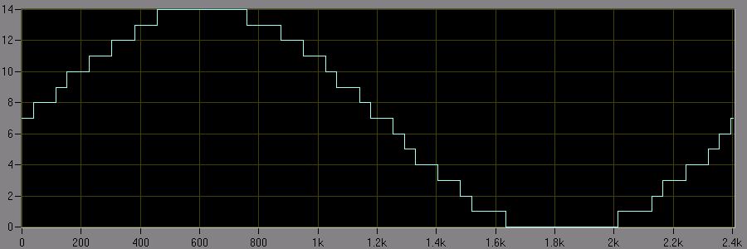

All the values of the sinewave are pulse width modulated (PWM) at a 5V digital output of the processor:
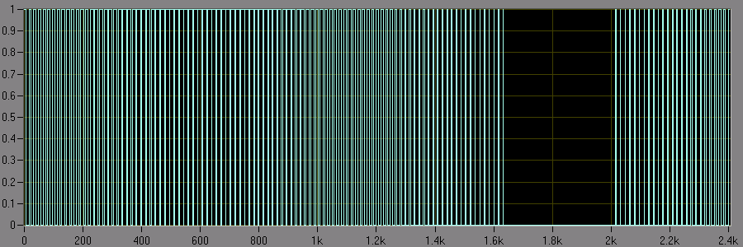

The spectrum looks like:
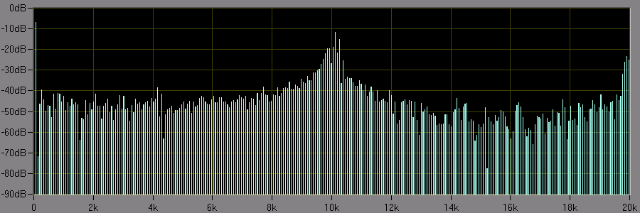
There is a good approach of a real sine wave, the harmonics within the 2kHz audio spectrum are negligible. The noise around 10kHz comes from the PWM modulation:

-CPU clock =20MHz, internally divided by 4 = 5MHz for each CPU instruction.
-The program always executes 31 instructions, so 5MHz / 31 results in a loop frequency of 161290Hz
-The modulation takes 16 program loops for one PWM period, therefore the 10080Hz is quite strong

The 10kHz pulses are divided in 16 periods, at 0 the dutycycle = 50%, 8 parts high and 8 parts low. At the rising part the next step will be 9 parts high and 7 parts low and so on.

The LC low pass filter (100nF and 12kOhm) reduces the 10kHz noise:
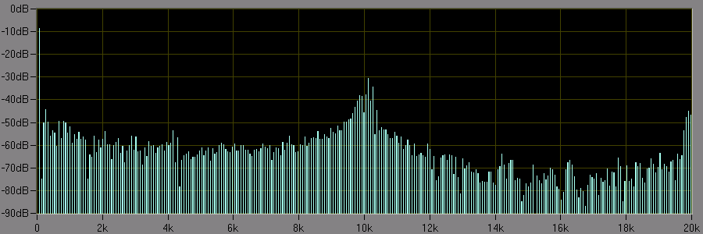

The result looks like:
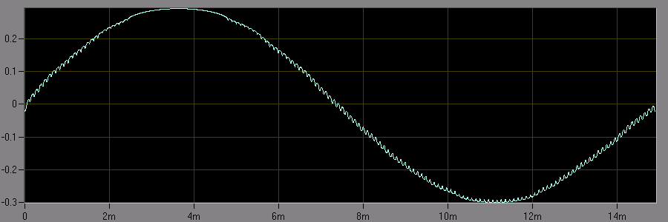

The small amount of 10kHz won’t affect the modulation. The remaining part will be filtered out.
Different tones

The looptime of the program is fixed, the period time of the tone of interest will be divided by the looptime. Eg. 82.5Hz is a period time of 12.12ms.

12.12ms / 6.2us = 1955.034. This is the number of the processor makes to complete one sinewave

The 1955.034 will be rounded to 1955, when calculating backwards the exact tone will be 82.50144 which is still more accurate than the official FX365.

The inputs B0 – B5 are used to select a tone, the processor polls the inputs and checks a table for the number of loops to execute. The number of loops is divided by 64 to determine after which loop the next part of the sine table should be read.

Pins: | Ideaal: |  | Periode fout: |  | Fout1: |  | Periode sample: |  |  |  | Fout in %: | FX365:
 |  |  | (Aantal loops) |  |  |  |  | 1/256
0 | 67 | 161290.32 | 2407.31825 | 2407 | 67.0088586 | 37.609375 | 37 | 156 | 2407 | 67.0088586 | 0.000132217 | 67.05
1 | 69.3 | 161290.32 | 2327.42168 | 2327 | 69.312558 | 36.359375 | 36 | 92 | 2327 | 69.312558 | 0.000181213 | 69.32
2 | 71.9 | 161290.32 | 2243.25901 | 2243 | 71.9083025 | 35.046875 | 35 | 12 | 2243 | 71.9083025 | 0.000115473 | 71.9
3 | 74.4 | 161290.32 | 2167.88068 | 2168 | 74.3959052 | 33.875 | 33 | 224 | 2168 | 74.3959052 | -5.5037E-05 | 74.35
4 | 77 | 161290.32 | 2094.67951 | 2095 | 76.9882208 | 32.734375 | 32 | 188 | 2095 | 76.9882208 | -0.000152977 | 76.96
5 | 79.7 | 161290.32 | 2023.71797 | 2024 | 79.6888946 | 31.625 | 31 | 160 | 2024 | 79.6888946 | -0.000139341 | 79.77
6 | 82.5 | 161290.32 | 1955.03421 | 1955 | 82.5014438 | 30.546875 | 30 | 140 | 1955 | 82.5014438 | 1.75003E-05 | 82.59
7 | 85.4 | 161290.32 | 1888.64546 | 1889 | 85.3839717 | 29.515625 | 29 | 132 | 1889 | 85.3839717 | -0.000187685 | 85.38
8 | 88.5 | 161290.32 | 1822.48952 | 1822 | 88.5237775 | 28.46875 | 28 | 120 | 1822 | 88.5237775 | 0.000268672 | 88.61
9 | 91.5 | 161290.32 | 1762.73577 | 1763 | 91.4862862 | 27.546875 | 27 | 140 | 1763 | 91.4862862 | -0.000149878 | 91.58
10 | 94.8 | 161290.32 | 1701.37471 | 1701 | 94.8208834 | 26.578125 | 26 | 148 | 1701 | 94.8208834 | 0.000220289 | 94.76
11 | 97.4 | 161290.32 | 1655.95814 | 1656 | 97.3975378 | 25.875 | 25 | 224 | 1656 | 97.3975378 | -2.52794E-05 | 97.29
12 | 100 | 161290.32 | 1612.90323 | 1613 | 99.9940004 | 25.203125 | 25 | 52 | 1613 | 99.9940004 | -5.99964E-05 | 99.96
13 | 103.5 | 161290.32 | 1558.3606 | 1558 | 103.523955 | 24.34375 | 24 | 88 | 1558 | 103.523955 | 0.000231454 | 103.43
14 | 107.2 | 161290.32 | 1504.5739 | 1505 | 107.16965 | 23.515625 | 23 | 132 | 1505 | 107.16965 | -0.00028312 | 107.15
15 | 110.9 | 161290.32 | 1454.37622 | 1454 | 110.928695 | 22.71875 | 22 | 184 | 1454 | 110.928695 | 0.000258747 | 110.77
16 | 114.8 | 161290.32 | 1404.96797 | 1405 | 114.797383 | 21.953125 | 21 | 244 | 1405 | 114.797383 | -2.27995E-05 | 114.64
17 | 118.8 | 161290.32 | 1357.66265 | 1358 | 118.770488 | 21.21875 | 21 | 56 | 1358 | 118.770488 | -0.000248418 | 118.8
18 | 123 | 161290.32 | 1311.30344 | 1311 | 123.028469 | 20.484375 | 20 | 124 | 1311 | 123.028469 | 0.000231454 | 122.8
19 | 127.3 | 161290.32 | 1267.0096 | 1267 | 127.300965 | 19.796875 | 19 | 204 | 1267 | 127.300965 | 7.58006E-06 | 127.08
20 | 131.8 | 161290.32 | 1223.75055 | 1224 | 131.773139 | 19.125 | 19 | 32 | 1224 | 131.773139 | -0.000203798 | 131.67
21 | 136.5 | 161290.32 | 1181.61408 | 1182 | 136.455434 | 18.46875 | 18 | 120 | 1182 | 136.455434 | -0.000326493 | 136.61
22 | 141.3 | 161290.32 | 1141.47433 | 1141 | 141.35874 | 17.828125 | 17 | 212 | 1141 | 141.35874 | 0.000415713 | 141.32
23 | 146.2 | 161290.32 | 1103.21698 | 1103 | 146.22876 | 17.234375 | 17 | 60 | 1103 | 146.22876 | 0.000196719 | 146.37
24 | 151.4 | 161290.32 | 1065.32578 | 1065 | 151.446312 | 16.640625 | 16 | 164 | 1065 | 151.446312 | 0.000305894 | 151.09
25 | 156.7 | 161290.32 | 1029.2937 | 1029 | 156.744726 | 16.078125 | 16 | 20 | 1029 | 156.744726 | 0.000285421 | 156.88
26 | 162.2 | 161290.32 | 994.391631 | 994 | 162.263906 | 15.53125 | 15 | 136 | 994 | 162.263906 | 0.000393995 | 162.31
27 | 167.9 | 161290.32 | 960.633249 | 961 | 167.835924 | 15.015625 | 15 | 4 | 961 | 167.835924 | -0.000381634 | 168.14
28 | 173.8 | 161290.32 | 928.02257 | 928 | 173.804227 | 14.5 | 14 | 128 | 928 | 173.804227 | 2.43206E-05 | 173.48
29 | 179.9 | 161290.32 | 896.555434 | 897 | 179.810839 | 14.015625 | 14 | 4 | 897 | 179.810839 | -0.000495614 | 180.15
30 | 186.2 | 161290.32 | 866.220852 | 866 | 186.247486 | 13.53125 | 13 | 136 | 866 | 186.247486 | 0.000255025 | 186.29
31 | 192.8 | 161290.32 | 836.568063 | 837 | 192.700505 | 13.078125 | 13 | 20 | 837 | 192.700505 | -0.000516054 | 192.86
32 | 203.5 | 161290.32 | 792.581438 | 793 | 203.392588 | 12.390625 | 12 | 100 | 793 | 203.392588 | -0.000527821 | 203.65
33 | 210.7 | 161290.32 | 765.497497 | 765 | 210.837023 | 11.953125 | 11 | 244 | 765 | 210.837023 | 0.000650323 | 210.17
34 | 218.1 | 161290.32 | 739.524634 | 740 | 217.959895 | 11.5625 | 11 | 144 | 740 | 217.959895 | -0.000642387 | 218.58
35 | 225.7 | 161290.32 | 714.622608 | 715 | 225.580871 | 11.171875 | 11 | 44 | 715 | 225.580871 | -0.000527821 | 226.12
36 | 233.6 | 161290.32 | 690.455148 | 690 | 233.754091 | 10.78125 | 10 | 200 | 690 | 233.754091 | 0.000659635 | 234.19
37 | 241.8 | 161290.32 | 667.040209 | 667 | 241.814577 | 10.421875 | 10 | 108 | 667 | 241.814577 | 6.02836E-05 | 241.08
38 | 250.3 | 161290.32 | 644.388025 | 644 | 250.450811 | 10.0625 | 10 | 16 | 644 | 250.450811 | 0.000602523 | 250.28
39 | 1124 | 161290.32 | 143.496728 | 143 | 1127.90435 | 2.234375 | 2 | 60 | 143 | 1127.90435 | 0.003473624
40 | 1197 | 161290.32 | 134.745466 | 135 | 1194.74313 | 2.109375 | 2 | 28 | 135 | 1194.74313 | -0.001885438
41 | 1275 | 161290.32 | 126.502214 | 127 | 1270.00254 | 1.984375 | 1 | 252 | 127 | 1270.00254 | -0.003919576
42 | 1358 | 161290.32 | 118.770488 | 119 | 1355.38086 | 1.859375 | 1 | 220 | 119 | 1355.38086 | -0.001928673
43 | 1446 | 161290.32 | 111.542408 | 112 | 1440.09217 | 1.75 | 1 | 192 | 112 | 1440.09217 | -0.004085639
44 | 1540 | 161290.32 | 104.733976 | 105 | 1536.09831 | 1.640625 | 1 | 164 | 105 | 1536.09831 | -0.002533565
45 | 1640 | 161290.32 | 98.3477577 | 98 | 1645.81962 | 1.53125 | 1 | 136 | 98 | 1645.81962 | 0.003548548
46 | 1747 | 161290.32 | 92.3241686 | 92 | 1753.15568 | 1.4375 | 1 | 112 | 92 | 1753.15568 | 0.003523572
47 | 1860 | 161290.32 | 86.7152272 | 87 | 1853.91175 | 1.359375 | 1 | 92 | 87 | 1853.91175 | -0.003273251
48 | 2400 | 161290.32 | 67.2043011 | 67 | 2407.31825 | 1.046875 | 1 | 12 | 67 | 2407.31825 | 0.00304927
49 | 1060 | 161290.32 | 152.160682 | 152 | 1061.12054 | 2.375 | 2 | 96 | 152 | 1061.12054 | 0.001057116
50 | 1160 | 161290.32 | 139.043382 | 139 | 1160.36203 | 2.171875 | 2 | 44 | 139 | 1160.36203 | 0.000312097
51 | 1270 | 161290.32 | 127.000254 | 127 | 1270.00254 | 1.984375 | 1 | 252 | 127 | 1270.00254 | 2E-06
52 | 1400 | 161290.32 | 115.207373 | 115 | 1402.52454 | 1.796875 | 1 | 204 | 115 | 1402.52454 | 0.001803246
53 | 1530 | 161290.32 | 105.418511 | 105 | 1536.09831 | 1.640625 | 1 | 164 | 105 | 1536.09831 | 0.003985824
54 | 1670 | 161290.32 | 96.5810315 | 97 | 1662.78683 | 1.515625 | 1 | 132 | 97 | 1662.78683 | -0.004319263
55 | 1830 | 161290.32 | 88.1367883 | 88 | 1832.84457 | 1.375 | 1 | 96 | 88 | 1832.84457 | 0.001554412
56 | 2000 | 161290.32 | 80.6451613 | 81 | 1991.23855 | 1.265625 | 1 | 68 | 81 | 1991.23855 | -0.004380725
57 | 2200 | 161290.32 | 73.313783 | 73 | 2209.45647 | 1.140625 | 1 | 36 | 73 | 2209.45647 | 0.004298397
58 | 1981 | 161290.32 | 81.4186384 | 81 | 1991.23855 | 1.265625 | 1 | 68 | 81 | 1991.23855 | 0.005168375
59 | 970 | 161290.32 | 166.278683 | 166 | 971.628449 | 2.59375 | 2 | 152 | 166 | 971.628449 | 0.001678814
60 | 810 | 161290.32 | 199.123855 | 199 | 810.504134 | 3.109375 | 3 | 28 | 199 | 810.504134 | 0.000622387
61 | 2800 | 161290.32 | 57.6036866 | 58 | 2780.86763 | 0.90625 | 0 | 232 | 58 | 2780.86763 | -0.006832989
62 | 2600 | 161290.32 | 62.0347395 | 62 | 2601.45682 | 0.96875 | 0 | 248 | 62 | 2601.45682 | 0.000560314
63 | 1750 | 161290.32 | 92.1658986 | 92 | 1753.15568 | 1.4375 | 1 | 112 | 92 | 1753.15568 | 0.001803246
Schematic diagram:

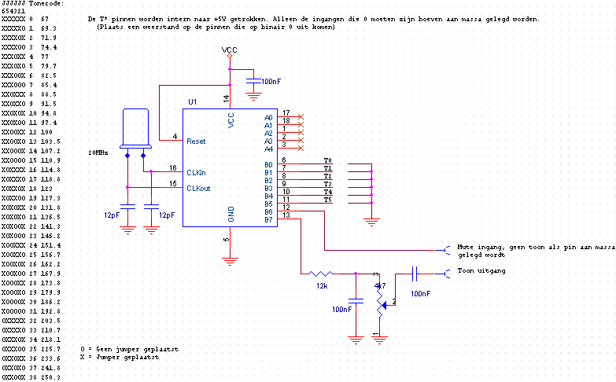
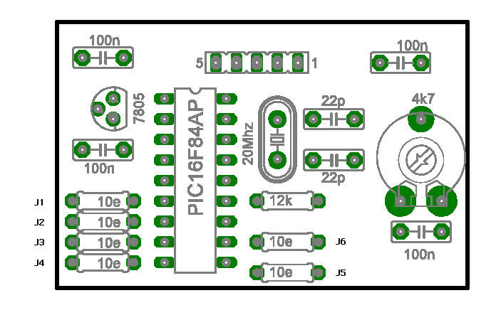

Mute Switch to GND to mute
GND GND
+12V +12V
Out CTCSS tone output,
variable from 0 to ~3V

Voor 82.5Hz:
J1 Draadbrug gelegd
J2 Open gelaten
J3 Open gelaten
J4 Draadbrug gelegd
J5 Draadbrug gelegd
J6 Draadbrug gelegd

Afhankelijk van de toepassing zal er een weerstand van 100k tussen de gele toon-uitgang en de set geplaatst moeten worden om het signaal te vezwakken. De voorkeur is het CTCSS signaal ná de mikrofoonversterker in te koppelen. Voor zenders met een laagohmige ingang (dynamische mikrofoon) is het aan te raden de 100nF condensator aan de uitgang naar de gele draad te vervangen door 10uF. Dit is erg afhankelijk van de zender zelf.

Meer informate www.muntronde.nl\RZGHVN aan de linker kant vind u de link ‘Subtoon’

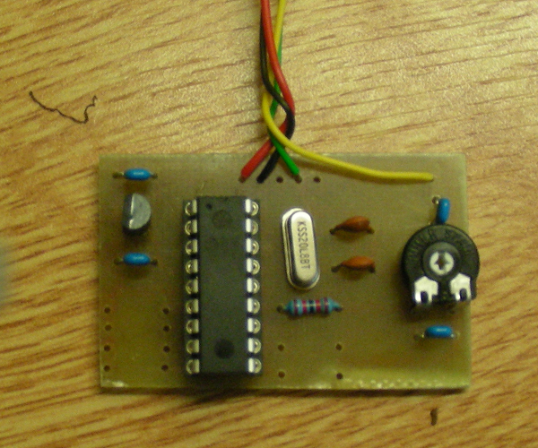
Audio results
Spectrum by Cooledit pro:

